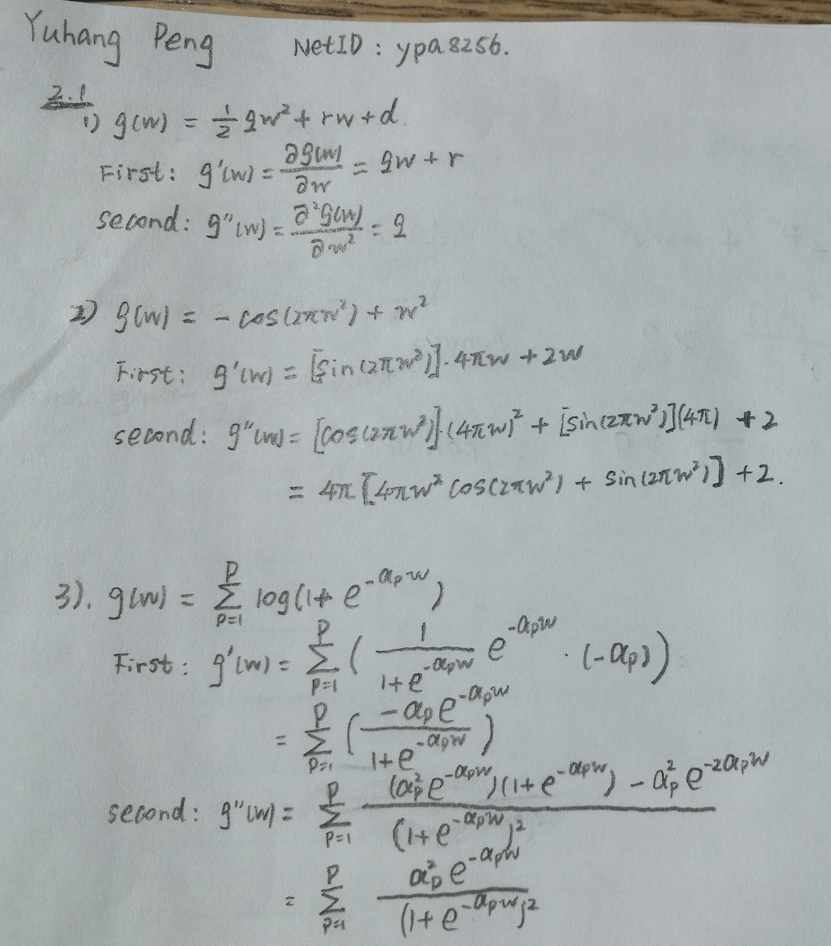

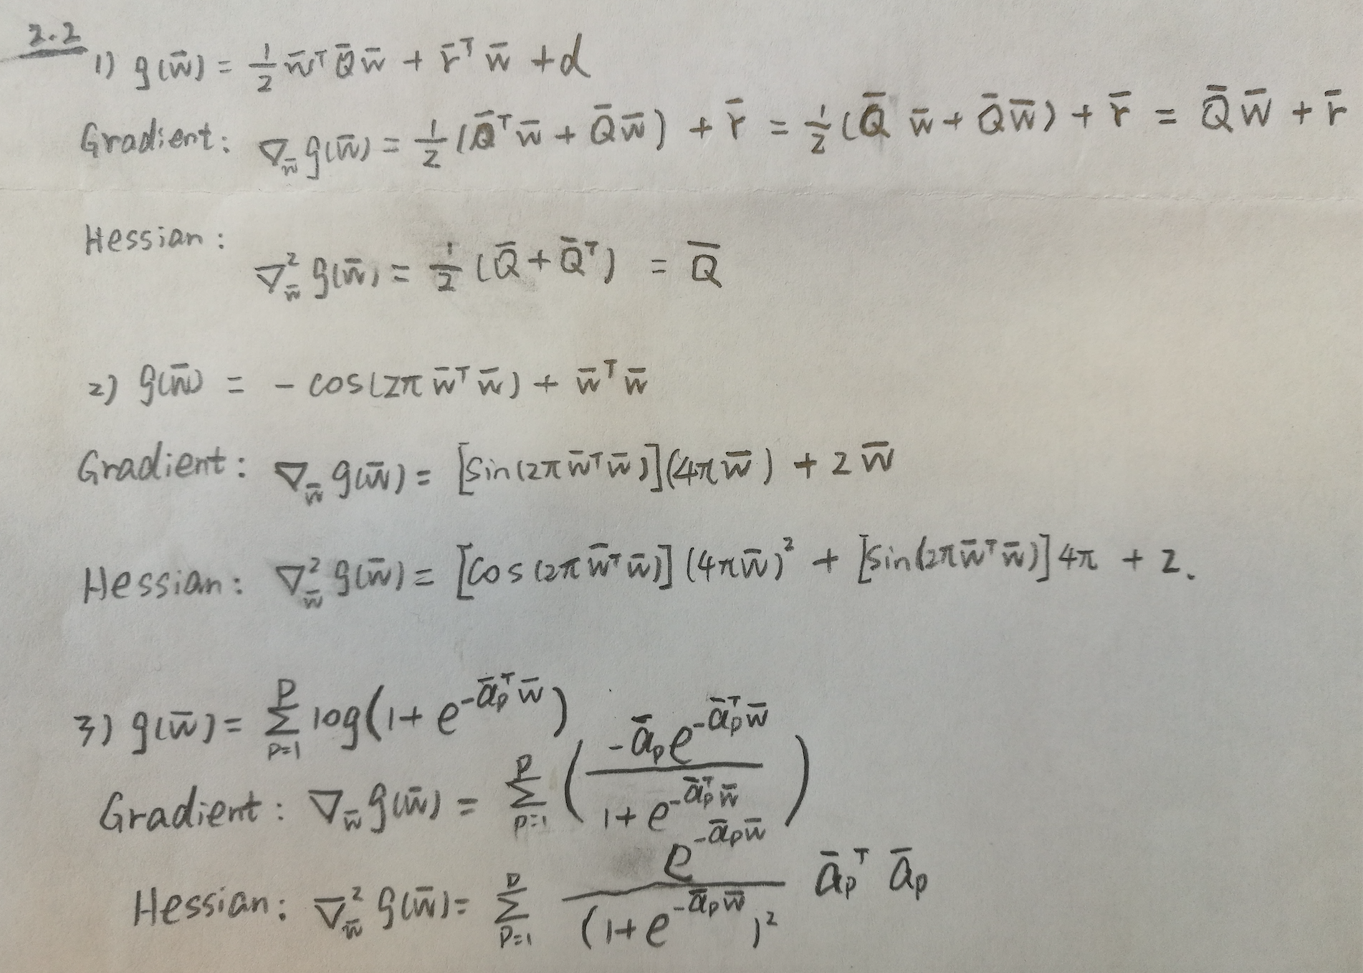

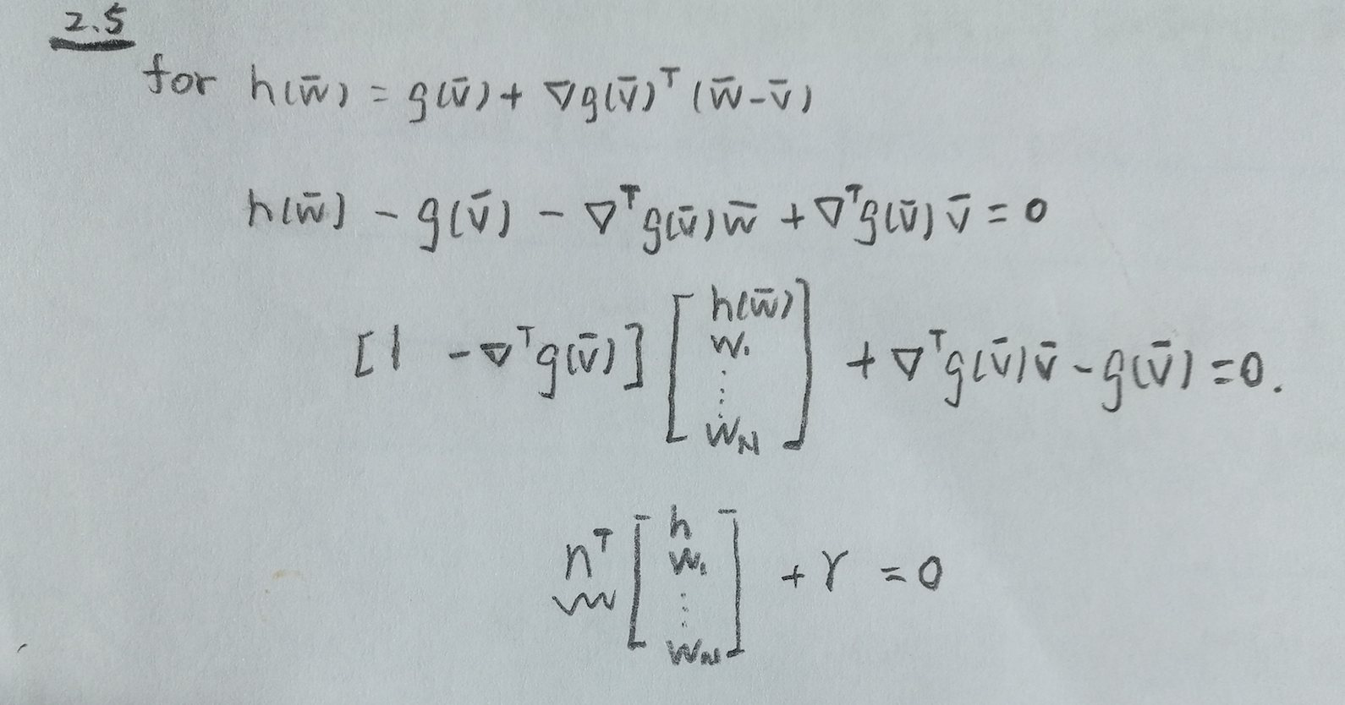

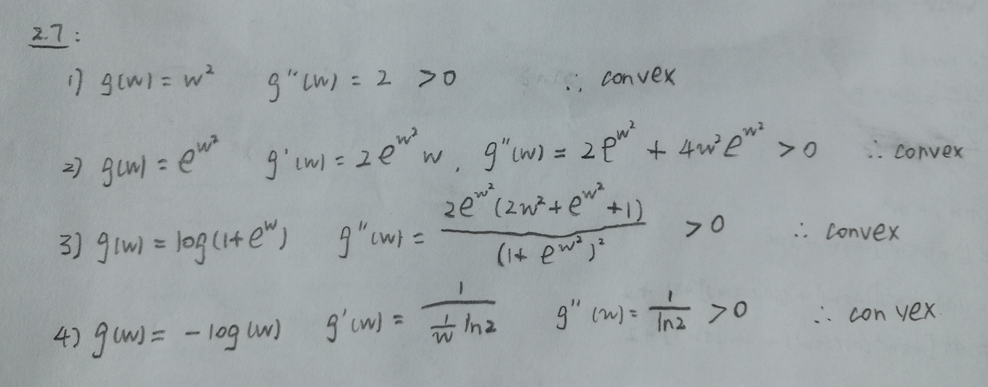

2.8

(1) $g\left(w\right)=w∙tanh⁡(w)$

$\frac{dg(w)}{dw}=\tanh\left(w\right)-w∙({\left(tanh\left(w\right)\right)}^{2}-1)$

After we that the first order equal to 0, then we can obtain that w = 0.

This figure show the $\frac{dg(w)}{dw}$, and we can find that w = 0 is the stationary point.

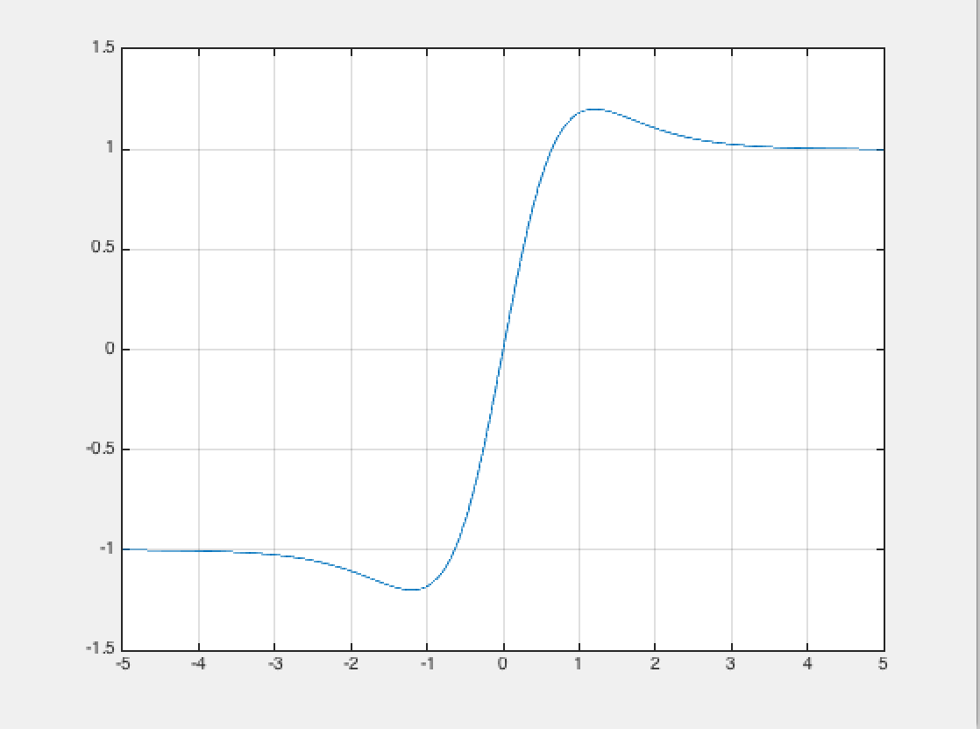

To check the answer, we plot the g(w), that shows the stationary point is the global minimal point.

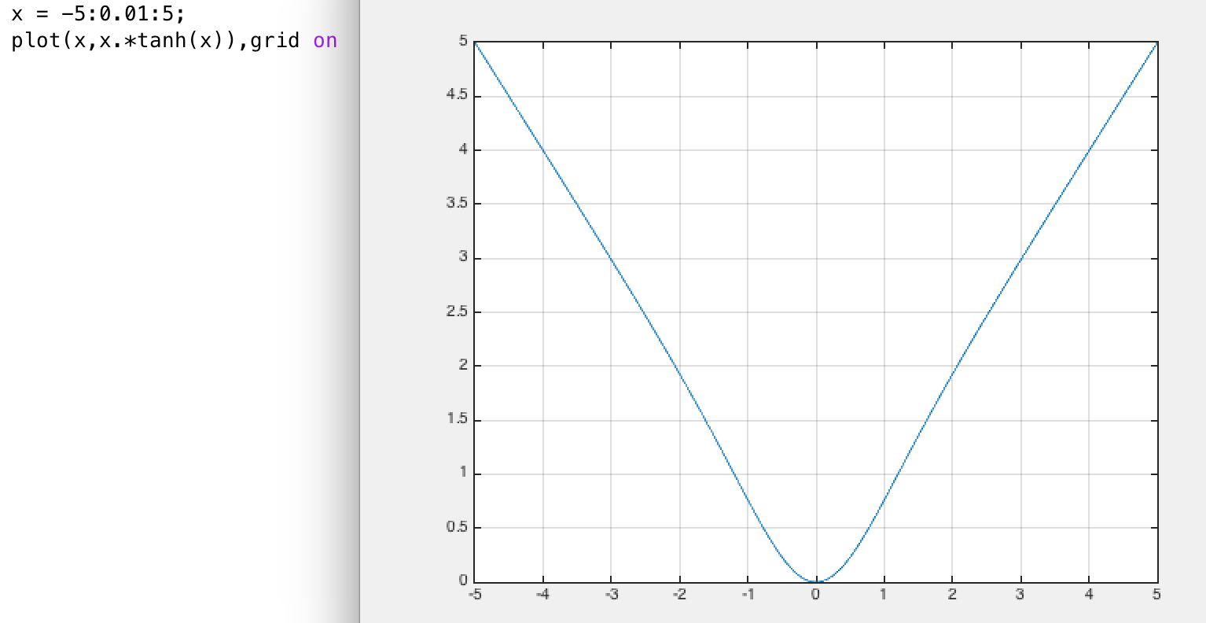

(2)

After plot the second order of the g(w), g’’(w) < 0 at some point, so it is non-convex

